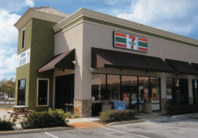

Date __________________

I hereby certify that I am a DUE PAYING MEMBER in the Columbia Pacific 7-Eleven Franchise Owners Association, Inc

Name: ___________________________________________________________________

Store Address: _____________________________________________________________

City, State, Zip: _____________________________________________________________

Mailing Address if different then above:

Address: __________________________________________________________________

City, State, Zip: _____________________________________________________________

I, __________________________________________________________________________

of 7-Eleven Store(s) ___________________________________________________________

* Do hereby authorize 7-Eleven, Inc. to pay $___________ to the Columbia Pacific 7-Eleven Franchise Owners Association each month from my open account #970 for monthly dues until further notified by this franchisee in writing.
* I also authorize an addition $__________ charge for each location mentioned above.

Signature or Store Stamp: ______________________________________________________

Association Signature: __________________________________________________________

Please Return Completed Application to:

Jerry Crippen

5734 Table Rock Rd

Central Point, OR 97502

[Jcrip5734@clearwire.net](mailto:Jcrip5734@clearwire.net)